Hat World, Inc

Functional Requirements: Customer Insights – Journeys (CIJ) Application

Table of Contents

Table of Contents 1

Document Purpose 2

Overview 2

Project Objectives 3

Customer Insights – Journeys (CIJ) Functional Requirements 3

1. Configuration of Emails 3

2. Configuration of Content Blocks 5

3. Configuration of Segment based Journeys in Customer Insights - Journeys 6

4. Configuration of Subscription Management form in Customer Insights - Journeys 10

5. Configuration of a Marketing Form for opt-in 11

6. Configuration of Marketing Security Roles 11

Customer Approval 13

# Document Purpose

This functional requirement document describes application related changes required to meet the desired business requirements as they relate to the application identified for deployment.

This list of requirements approved will be considered final upon acceptance as indicated by the customer’s signature.

**Version History**

|  |  |  |  |
| --- | --- | --- | --- |
| **Version** | **Author** | **Date** | **Notes** |
| 1.0 | Jinali Kamdar | 02/02/2024 | Initial Draft |
|  |  |  |  |
|  |  |  |  |

Overview

Hat World is currently using Acquia to send out their marketing emails and looking to move to Microsoft’s Customer Insights – Journeys platform.

## Project Objectives

**Customer Insights - Journeys in-scope summary for Build phase**

* Baseline application settings/Environment setup
* Configuration of up to 10 Emails
* Configuration of up to 3 Content block
* Configuration of up to 10 journeys
* Configuration of subscription management form in Customer Insights - Journeys
* Consent Management and CCPA Compliance
* Configuration of 2 Marketing security roles (1 Admin ,1 General user)

# Customer Insights – Journeys (CIJ) Functional Requirements

## Configuration of Emails

The following emails will be configured in Lids Customer Insights – Journeys environment. The Lids team will be trained to create additional emails as needed.

|  |  |  |  |
| --- | --- | --- | --- |
| **Sr. No** | **Emails** | **Journey** | **Notes** |
| **1.** | Access Pass Welcome | Welcome Journey | This email will be created based on the template shared by Lids team. |
| **2.** | Access Pass Welcome | Fan Outfitters Welcome Journey | This email will be created based on the template shared by Lids team. |
| **3.** | Access Pass Premium Welcome | Welcome Journey and New Premium Member Journey | This email will be created based on the template shared by Lids team. |
| **4.** | Access Pass Premium Welcome | Fan Outfitters Welcome Journey | This email will be created based on the template shared by Lids team. |
| **5.** | Access Pass Account Login/League & Team Preferences | Welcome Journey | This email will be created based on the template shared by Lids team. |
| **6.** | Access Pass Account Login/League & Team Preferences | Fan Outfitters Welcome Journey | This email will be created based on the template shared by Lids team. |
| **7.** | Access Pass Email Preferences | Welcome Journey | This email will be created based on the template shared by Lids team. |
| **8.** | Access Pass Email Preferences | Fan Outfitters Welcome Journey | This email will be created based on the template shared by Lids team. |
| **9.** | Access Pass Up Sale to Premium | Welcome Journey | This email will be created based on the template shared by Lids team. |
| **10.** | Access Pass Up Sale to Premium | Fan Outfitters Welcome Journey | This email will be created based on the template shared by Lids team. |
| **11.** | Access Pass Monthly Snapshot | Monthly Snapshot Journey | This email will be created based on the template shared by Lids team. |
| **12.** | Access Pass Premium Membership Expiring in 30 days | Membership Expiring Journey | This email will be created based on the template shared by Lids team. |
| **13.** | Access Pass Premium Membership Expiring in 14 days | Membership Expiring Journey | This email will be created based on the template shared by Lids team. |
| **14.** | Access Pass Premium Membership Expiring in 7 days | Membership Expiring Journey | This email will be created based on the template shared by Lids team. |
| **15.** | Access Pass Premium Membership Expiring in 3 days | Membership Expiring Journey | This email will be created based on the template shared by Lids team. |
| **16.** | Access Pass Premium Membership Expiring in 1 days | Membership Expiring Journey | This email will be created based on the template shared by Lids team. |
| **17.** | Access Pass You lost your premium benefits | Membership Expiring Journey | This email will be created based on the template shared by Lids team. |
|  | ~~Access Pass Almost There~~ | ~~Almost There Journey~~ | ~~This email will be created based on the template shared by Lids team.~~ |
|  | ~~Access Pass Reward Earned~~ | ~~Reward Earned Journey~~ | ~~This email will be created based on the template shared by Lids team.~~ |

* + The following corporate address will be used in all marketing emails: 7676 Interactive Way, Suite 300, Indianapolis, IN 46278
  + The following email addresses will be used to send out the emails:
    - [Lids@mt.lids.com](mailto:Lids@mt.lids.com) – Lids
    - [Dodgers@mt.lids.com](mailto:Dodgers@mt.lids.com) – Dodgers Clubhouse
    - [Yankees@mt.lids.com](mailto:Yankees@mt.lids.com) – Yankees Clubhouse
    - [FanOutfitters@mt.lids.com](mailto:FanOutfitters@mt.lids.com) – Fan Outfitters
    - [NBAStore@mt.lids.com](mailto:NBAStore@mt.lids.com) – NBA Store
    - [NHLShop@mt.lids.com](mailto:NHLShop@mt.lids.com) – NHL Shop
    - [LidsHD@mt.lids.com](mailto:LidsHD@mt.lids.com) – Lids HD
    - [Ebbets@mt.lids.com](mailto:Ebbets@mt.lids.com) – Ebbets Field Flannels
    - [CustomLids@mt.lids.com](mailto:CustomLids@mt.lids.com) – Custom Lids
    - [BuckeyeCorner@mt.lids.com](mailto:BuckeyeCorner@mt.lids.com) – Buckeye Corner
    - [Fanatics@mt.lids.com](mailto:Fanatics@mt.lids.com) - Fanatics
  + The reply to email address for all marketing emails would be [customercare@lids.com](mailto:customercare@lids.com)
  + Brooklynn to share the email template images.

## Configuration of Content Blocks

The following Content Blocks will be created as part of this implementation.

* + - Lids
    - Lids HD
    - NBA Store
    - NHL Shop
    - Dodgers Clubhouse
    - Yankees Clubhouse
    - Fan Outfitters – pending to be shared.

**Social Media Icon Footers for Content Blocks:**

|  |  |  |
| --- | --- | --- |
| **1.** | Lids | Instagram <https://www.instagram.com/lids/>  Facebook <https://www.facebook.com/Lids>  X <https://twitter.com/lids>  YouTube <https://www.youtube.com/lids>  TikTok https://www.tiktok.com/@lids_loyal |
| **2.** | Lids HD | Instagram <https://www.instagram.com/lidshatdrop/>  Facebook https://www.facebook.com/lidshatdrop |
| **3.** | Dodgers Clubhouse | Instagram https://www.instagram.com/dodgersclubhouse/  Facebook https://www.facebook.com/DodgersClubhouse/ |
| **4.** | Yankees Clubhouse | Facebook https://www.facebook.com/yankeeclubhouse/ |
| **5.** | NBA Store | Instagram https://www.instagram.com/nbastore/  Facebook https://www.facebook.com/NBAStore/  X https://twitter.com/nbastore |
| **6.** | NHL Shop | Instagram https://www.instagram.com/officialnhlshop/  Facebook <https://www.facebook.com/NHLShop/>  X https://twitter.com/nhl_shop |
| **7.** | Fan Outfitters |  |

## Configuration of Segment based Journeys in Customer Insights - Journeys

TTEC Digital will configure the following journeys as part of this implementation and will train the Lids team to create additional journeys as needed.

|  |  |  |
| --- | --- | --- |
| **Sr. No** | **Journeys** | **Notes** |
| **1.** | Welcome Journey | The segment for this journey will be created in CI-Data application |
| **2.** | New Premium Member Journey | The segment for this journey will be created in CI-Data application |
| **~~3.~~** | ~~Almost There Journey~~ | ~~The segment for this journey will be created in CI-Data application~~ |
| **~~4.~~** | ~~Reward Earned Journey~~ | ~~The segment for this journey will be created in CI-Data application~~ |
| **5.** | Membership Expiring Journey | The segment for this journey will be created in CI-Data application |
| **6.** | Monthly Snapshot Journey | The segment for this journey will be created in CI-Data application |
| **7.** | Points Expiring Journey | Brooklynn to confirm with Robert whether its needed or covered in Monthly Snapshot Journey. |
| **8.** | Fan Outfitters Welcome Journey | The segment for this journey will be created in CI-Data application |

Below is the screenshot for reference for Journeys:

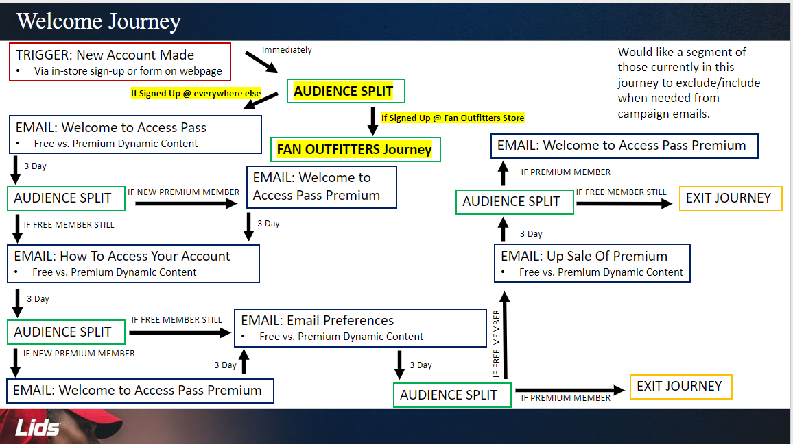

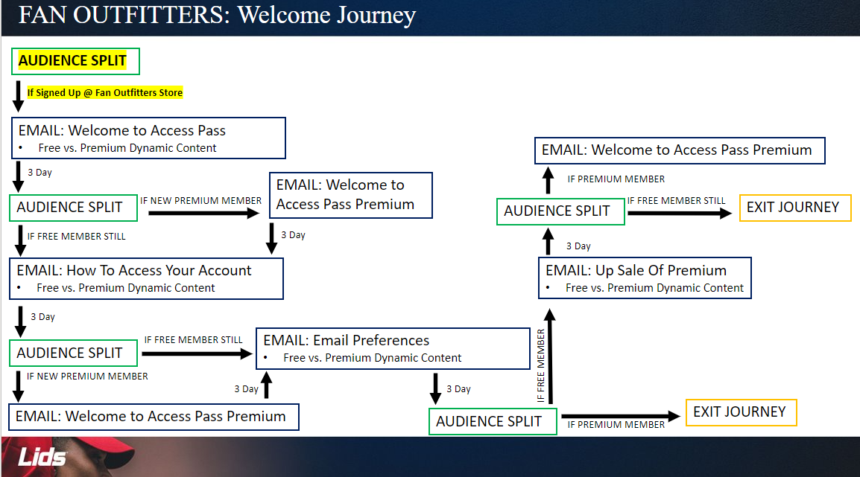

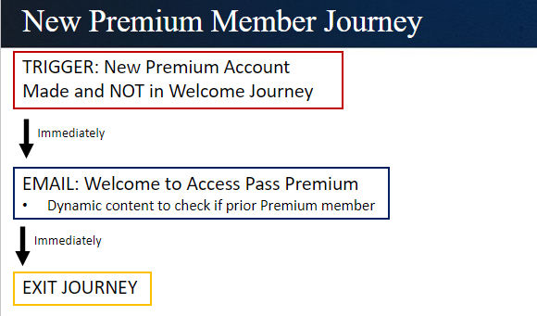

~~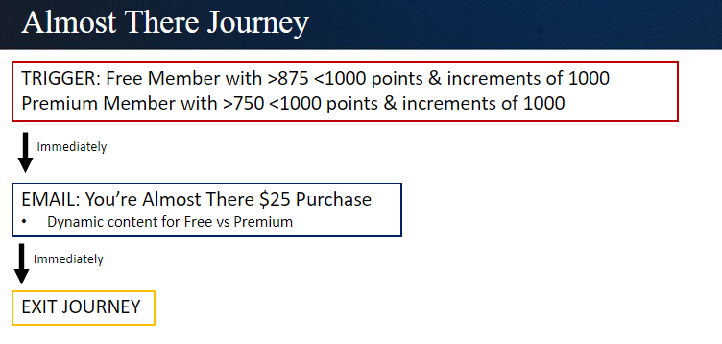~~

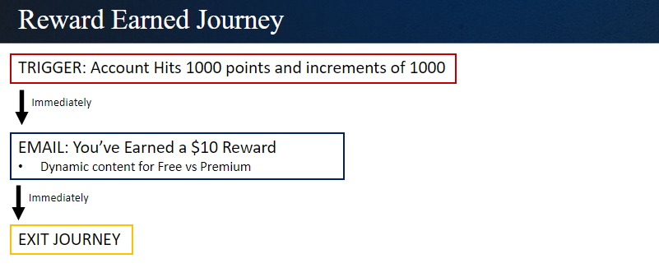

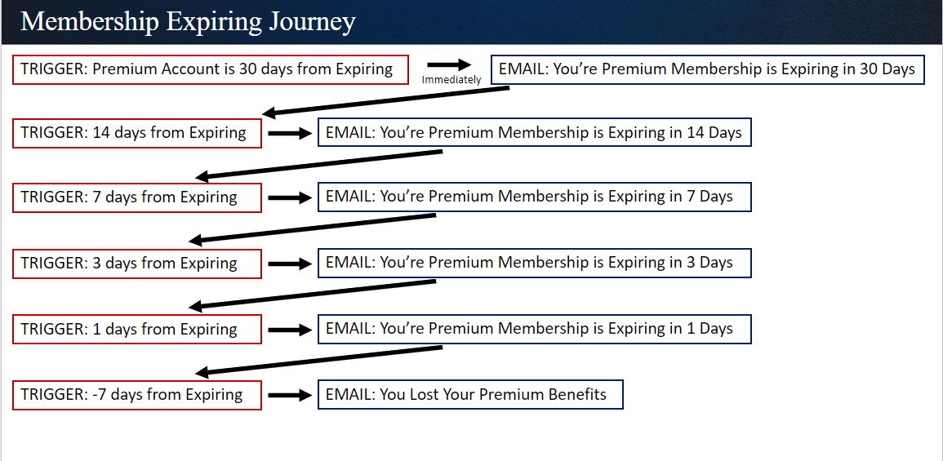

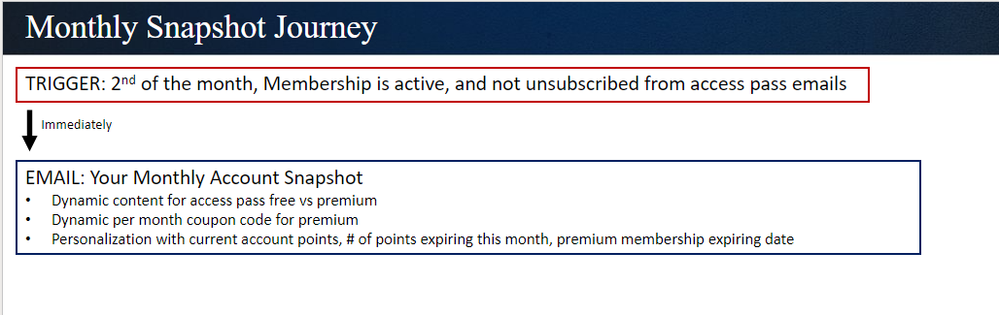

## Configuration of Subscription Management form in Customer Insights – Journeys

TTEC Digital will create 2 compliance profiles and configure the preference center/ unsubscribe form to allow contacts to unsubscribe or to manage their preferences. The current Acquia Unsubscribe form will be used for design reference.

1. Lids – Lids Unsubscribe form will be used in all Lids emails except the Fan Outfitters emails.
2. Fan Outfitters – This unsubscribed form will exclusively be used for Fan outfitters emails.

The following rules apply to both the forms:

a. The following text will be displayed when the customer submits the unsubscribed form: Thank you, you will be unsubscribed from all the marketing emails within a week. If you’d like to re-subscribe, please use the link below.

b. A link will be added to allow customers to opt back in on the confirmation page.

## Configuration of a Marketing Form for opt-in

A Marketing form will be created to allow contacts to subscribe to emails.

|  |  |  |
| --- | --- | --- |
| **Sr. No** | **Form** | **Purpose** |
| **1.** | Re-Subscribe Form | To allow customers to re-subscribe to emails after they have unsubscribed |
| **2.** | Email Opt-in Form | To allow customers to opt-in to all emails or specific subscription lists/topics |

## Configuration of Marketing Security Roles

TTEC Digital will create 2 marketing security roles as part of this CI – Journeys implementation. One is a basic marketing professional/user role, and the other one is a marketing manager/admin role. These roles will have different levels of access for various tables in the CI – Journeys application.

|  |  |
| --- | --- |
| **Role Name** | **Access Needed** |
| **Marketing Professional-Business** | This user level role will allow users to create/update/manage their own marketing records like emails, segments, templates etc. Detailed security permissions will be discussed during the build phase. |
| **Marketing Manager-Business** | This admin level role will allow users to create/update/manage/delete any marketing records like emails, segments, templates etc. Detailed security permissions will be discussed during the build phase. |

We will build the security roles based on these permissions mentioned below:

**1. Marketing Professional/User:**

|  |  |  |  |  |  |
| --- | --- | --- | --- | --- | --- |
|  | **Create** | **Read** | **Write** | **Delete** | **Assign** |
| **Journey** | Organization | Organization | User | User | User |
| **Content Blocks** | Organization | Organization | User | User | User |
| **Email** | Organization | Organization | User | User | User |
| **Email Templates** | Organization | Organization | User | User | User |
| **Files/Assets (images etc.)** | Organization | Organization | User | User | User |
| **Preference Center** | None | Organization | None | None | None |

**2. Marketing Manager:**

|  |  |  |  |  |  |
| --- | --- | --- | --- | --- | --- |
|  | **Create** | **Read** | **Write** | **Delete** | **Assign** |
| **Journey** | Organization | Organization | Organization | Organization | Organization |
| **Content Blocks** | Organization | Organization | Organization | Organization | Organization |
| **Email** | Organization | Organization | Organization | Organization | Organization |
| **Email Templates** | Organization | Organization | Organization | Organization | Organization |
| **Files/Assets (images etc.)** | Organization | Organization | Organization | Organization | Organization |
| **Preference Center** | Organization | Organization | Organization | Organization | Organization |

1. **Consent Management and CCPA Compliance**
   1. **One time Consent**
   2. **On-going Consent**

Pending internal discussion for using ADF

1. **Domain Authentication**

The following domain will be authenticated in the Customer insights journey application:

**Mt.lids.com**

TTEC Digital will provide domain registration keys to the Lids team. Lids team will work with their DNS provider to add the registration keys to the DNS.

# Customer Approval

Hat World agrees with all the requirements for the Customer Insights – Journeys application presented above.

**Hat World, Inc TTEC Digital**, LLC

Name:         Name:

Title:             Title:

Date:                     Date: